*Check against delivery*

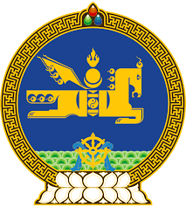

**46th SESSION OF THE UPR WORKING GROUP**

**MONGOLIA’S STATEMENT AT THE REVIEW OF VIET NAM**

**7 May 2024, 09:00 - 12:00 hrs**

(50 sec)

Thank you, Mr. President.

Mongolia takes positive note of the progress that Viet Nam has made in the implementation of the recommendations accepted during the previous cycle of the UPR.

In the spirit of constructive dialogue, Mongolia recommends Viet Nam to:

**One.** Consider extending a standing invitation to the special procedures of the Human Rights Council;

**Two.** Ratify the International Convention for the Protection of All Persons from Enforced Disappearance, and the Optional Protocol to the Convention on the Rights of the Child on a communications procedure;

**Three.** Further enhance its efforts to fight trafficking in persons, including women and girls, by protecting victims and taking preventive measures, among others;

**Four.** Accelerate its efforts to establish an independent national human rights institution, in compliance with the Paris Principles.

I thank you.

---oOo---