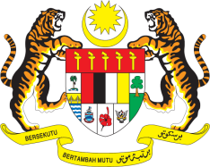

**STATEMENT BY MALAYSIA**

**REVIEW OF VIET NAM**

**46TH SESSION OF THE UPR WORKING GROUP**

**29 APRIL – 10 MAY 2024**

Malaysia commends Viet Nam for promoting human rights education and awareness as well as implementing international human rights obligations. On the regional front, Malaysia appreciates Viet Nam’s important contribution to the realisation of the ASEAN common human rights agenda.

2. In the spirit of constructive engagement, Malaysia recommends the following:

2.1 First, continue efforts to further develop human resources capacities and improve quality of life of the people, particularly in remote areas, including through the implementation of the 2021-2030 Socio-Economic Development Strategy and the 2021-2025 Socio-Economic Development Plan.

2.2 Second, effectively implement the National Action Plan on the eradication of mother-to-child transmission of HIV and the National Strategy to end AIDS by 2030, including the elimination of all forms of discrimination against people living with HIV.

3. We wish Viet Nam a successful review.

Thank you.

**7 MAY 2024**

**GENEVA**