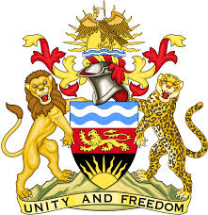

**REPUBLIC OF MALAWI**

**MALAWI STATEMENT ON VIETNAM UNIVERSAL PERIODIC REVIEW**

**TUESDAY, 7TH MAY 2024**

**Mr. President**,

Malawi welcomes Viet Nam to this review and thanks the delegation for the comprehensive presentation.

In the spirit of constructive dialogue, Malawi makes the following recommendations to Viet Nam:

1. Consider ratifying the International Convention for the Protection of All Persons from Enforced Disappearance.
2. Consider ratifying the Convention on the Status of Stateless Persons.
3. Continue with efforts to submit all outstanding human rights state party reports.

We wish Viet Nam all the best at this review and in the implementation of the recommendations.

**Thank you, Mr. President**.