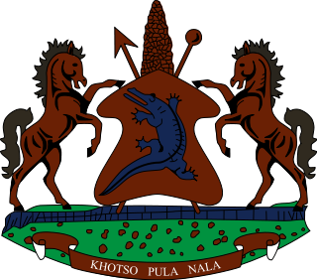

**INTERVENTION OF THE DELEGATION OF LESOTHO UNDER THE UPR REVIEW OF VIET NAM**

**7 MAY 2024**

**GENEVA, SWITZERLAND**

**Thank you, Mr. President,**

Lesotho welcomes the distinguished delegation of Viet Nam to the Working Group. We commend Viet Nam for its commitment to promoting human rights through legislative measures and international treaty ratifications. We highly appreciate Viet Nam's recent accession to the International Labor Organization's Forced Labor Convention.

Cognisant of these strides taken by Vietnam, Lesotho wishes to recommend Viet Nam to; 1. Strengthen efforts to ensure full respect for freedom of expression, association, and assembly, and protect these rights in practice and law; 2. Continue to address disparities in access to education, healthcare, and clean water, particularly for disadvantaged and marginalized communities and lastly, to strengthen measures to eliminate violence against women and girls and enhance public awareness of their rights, whilst working in cooperation with civil society organizations.

We wish to conclude by wishing the delegation of Viet Nam continued success in this cycle.

**Thank you.**