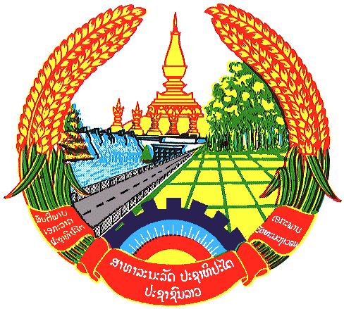

**Statement by the delegation of the Permanent Mission of the Lao PDR to the United Nations Office and other International Organizations in Geneva**

**at the 46th Session of UPR Working Group**

**Geneva, 7 May 2024**

(Speaking time 0.50 minute)

Review of Viet Nam (09:00 – 12:30)

1. Thank you, Mr. President.
2. My delegation warmly welcomes and thanks Viet Nam for presentation of the report.
3. The Lao PDR commends Viet Nam’s significant progress made in advancing human rights and development in the country since the last UPR cycle.
4. The Lao PDR recommends Viet Nam the followings:

**ONE:** Further ensure national food security and contribute to the assurance of regional and global food security; and

**TWO:** Prioritize resources and organize effective implementation of the National Target Program for sustainable poverty reduction in the period of 2021-2025.

1. We would also like to take this special opportunity to congratulate Viet Nam on the occasion of the 70th anniversary of victory at Dien Bien Phu on 7 May 1954, which laid the groundwork for independence and self-determination of the peoples of Indochina and their enjoyment of human rights.
2. We wish Viet Nam a successful review.
3. I thank you, Mr. President.