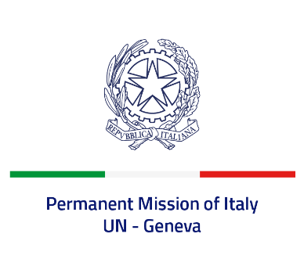

*Check against delivery*

**UPR 46 - Vietnam**

**Tuesday 7 May 2024, 9:00 - 12:30**

**Delivered by: Ambassador Vincenzo Grassi, Permanent Representative of Italy**

Thank you, Mister President.

Italy recognizes the efforts made by Vietnam to implement previous UPR recommendations and welcomes the process of a possible revision of its legislation to align it with international standards, including on persons with disabilities.

Italy would like to recommend to Vietnam to:

•        *Further reduce the list of offences punishable by the death penalty, with a view to establishing a moratorium, and consider publishing official data;*

•      *Guarantee the right to freedom of expression and opinion, and create an enabling environment for civil society;*

•       *Remove obstacles to the freedom of religion or belief and address any act of discrimination and violence against ethnic and religious minority groups;*

•        *Strengthen measures to protect children from all forms of violence and abuse.*

We wish Vietnam a successful review.

I thank you.