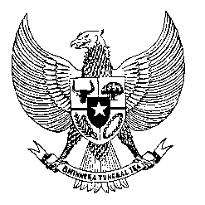

Permanent Mission
of the Republic of Indonesia to the UN, WTO,
and Other International Organizations
in Geneva

STATEMENT BY THE DELEGATION OF THE REPUBLIC OF INDONESIA
AT THE 46th SESSION OF THE UPR WORKING GROUP
CONSIDERATION OF THE UPR REPORT OF VIETNAM
7 MAY 2024

Mr. Vice President,

Indonesia thanks the esteemed delegation of Viet Nam for presenting its national report.

We commend Viet Nam’s commitment in implementing the accepted recommendations since the last UPR, including through the enactment of the Master Plan that assigned 18 Ministries responsible for implementing the recommendations.
As a fellow ASEAN member state and in the spirit of constructive engagement, Indonesia recommends the following:

- Step up efforts to ratify the International Convention on the Protection of the Rights of All Migrant Workers and Members of their Families.
- Redouble efforts to expand access to quality education, especially disadvantaged and vulnerable groups, including children with disabilities.
- Continue to enhance trainings and education on human rights for government officials, civil servants, business, media and youth.

We wish Viet Nam a successful review.

Thank you.

