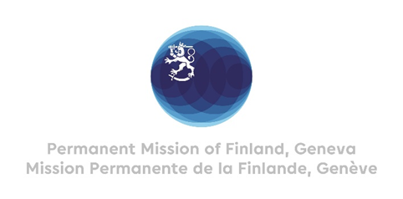

**46th Session of the UPR working group**

**Recommendations by Finland to Viet Nam**

**7th May 2024**

Mr. President,

Finland welcomes the engagement of Vietnam in the UPR process. We note the efforts made by Vietnam regarding the previous UPR cycle. Finland welcomes recent steps taken in prevention of discrimination based on sexual orientation and gender identity.

In a constructive spirit, Finland wishes to make the following recommendations:

1. One, to establish a moratorium on the death penalty, especially for non-violent crimes, with a view towards abolishing it.
2. Two, to ensure that freedom of expression, especially media freedom, and freedom of assembly are respected.
3. Three, to criminalize violence against women, and strengthen women’s access to justice and essential services for all survivors.

I thank you.