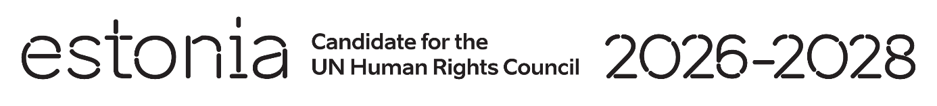

**Universal Periodic Review of the Viet Nam**

**7 May 2024**

**Intervention by the delegation of Estonia**

Estonia welcomes the delegation of the Viet Nam to its fourth UPR and acknowledges Viet Nam’s engagement in the UPR process. We welcome the steps taken to advance LGBTQI-rights.

We note with concern deficiencies in ensuring the enjoyment of the civil and political rights. We urge to release journalists and human rights defenders arbitrarily detained or sentenced to prison for exercising the right to freedom of opinion and expression.

We would like to recommend to Viet Nam:

* repeal or amend laws restricting the freedom of opinion and expression and access to the Internet by bringing them into line with international standards;
* criminalize violence against women, including marital rape and sexual abuse;
* intensify awareness-raising measures on domestic violence and its detrimental impact on the lives of victims;
* establish an official moratoirum on death penalty, starting with offenses that do not meet the most serious crime threshold, with the view of ratifying the Second Optional Protocol of the International Covenant on Civil and Political Rights, aiming at the abolition of the death penalty.

We wish Viet Nam a successful review.

Thank you.