**Permanent Mission of the Democratic People's Republic of Korea to the United Nations Office and Other International Organizations in Geneva**

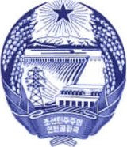

1. Chemin de Plonjon 1207 Geneva Tel: 022 735 4370 Fax: 022 786 0662

**Statement of the DPRK Delegation**

**on the 4th cycle UPR of Viet Nam**

(46th session of UPR Working Group, 7 May 2024)

Mr. President,

The DPRK delegation warmly welcomes the delegation of Viet Nam and commends the Government of Viet Nam for its efforts and tangible progress in the promotion and protection of human rights of its people.

In a constructive spirit, we recommend followings;

1. Continue to develop models of poverty eradication and livelihood support for people with disabilities,
2. Continue to provide vocational training, start-up support, and introduce business opportunities to people with disabilities,
3. Prioritize social security for vulnerable groups, especially the elderly, people with disabilities in socio-economic development.

We wish Viet Nam successful review.

Thank you.