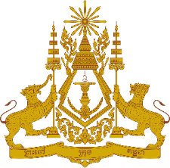

**PERMANENT MISSION OF THE KINGDOM OF CAMBODIA**

**TO THE UNITED NATIONS AT GENEVA**

**Statement of Cambodia**

At the 46th Session of the UPR Working Group

UPR of Viet Nam

7 May 2024

(0 minutes and 50 seconds)

-------

Mr. President!

1. Cambodia warmly welcomes the distinguished delegation of Viet Nam.
2. We commend Viet Nam for its significant progress since the last UPR and its efforts to enhance socio-economic growth, eradicate poverty, and improve living conditions. We also applaud Viet Nam’s ongoing commitment to promoting women’s empowerment and gender equality through its national initiatives and policies.
3. In the constructive spirit, Cambodia recommends the following:
   1. Promote dialogue and cooperation at the Human Rights Council on the basis of respect and understanding to ensure all human rights.
   2. Continue to strengthen policies aimed at enhancing women’s empowerment in all areas, particularly in economics, science, and education.
4. We wish Viet Nam success in this review.

Thank you,

*\*\*\*\*\**