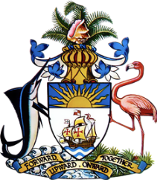

**Statement by  
 Permanent Mission of The Bahamas to the United Nations Office and other International Organizations in Geneva**

**at the 46th Session of the Universal Periodic Review Working Group**

***Presentation of UPR Report by Vietnam* 7May 2024**

Thank you, Mr. President,

The Bahamas thanks Vietnam for its comprehensive report and acknowledges the commendable progress made since the 3rd cycle of the UPR.

We commend Vietnam for its legislative reforms and policy advancements that have significantly contributed to human rights protections. The adoption of 45 new laws since 2019, aimed at aligning the domestic legal framework with international human rights standards, demonstrates a firm commitment to improving the socio-economic conditions of its people.

In a spirit of constructive dialogue, The Bahamas recommends that Vietnam:

1. Build on efforts in environmental protection and climate change mitigation,
2. Continue to promote women's participation in STEM fields and support women entrepreneurs, especially in rural areas.
3. Expand programs that facilitate youth engagement in civic activities and decision-making processes.

We extend our best wishes to Vietnam for a successful review.

I thank you.