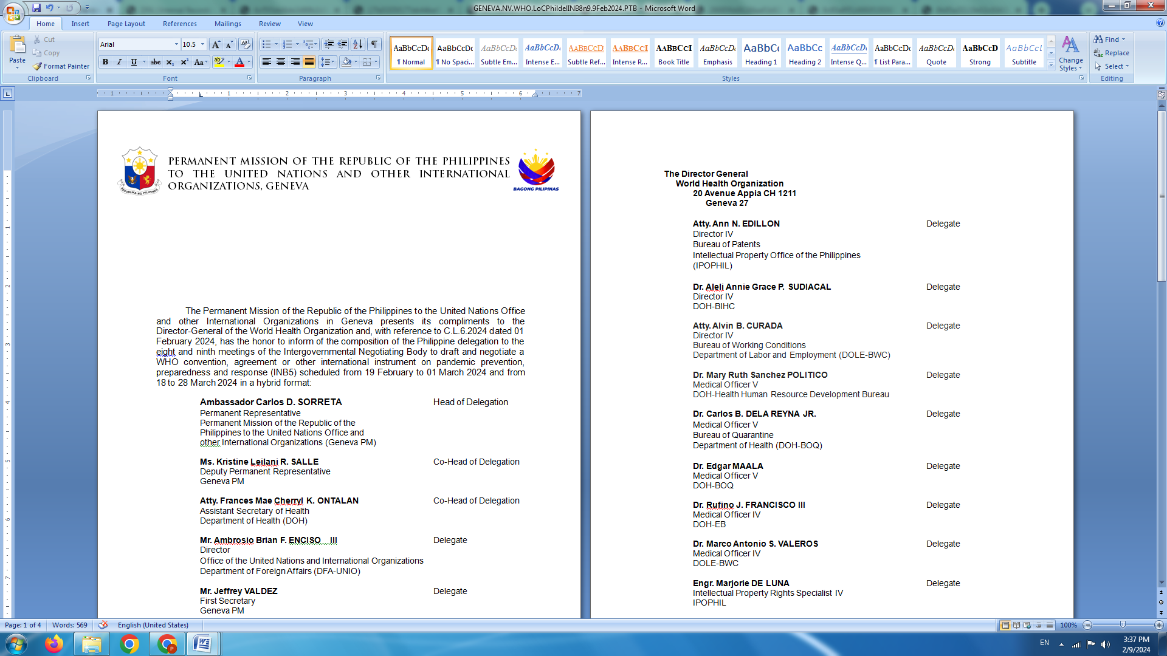

**P H I L I P P I N E S**

**HUMAN RIGHTS COUNCIL**

**46th Session of the Working Group on the Universal Periodic Review**

02 May 2024, Palais des Nations, Geneva, Switzerland

**UNIVERSAL PERIODIC REVIEW OF VANUATU**

*To be delivered by:*

**CARLOS D. SORRETA**

**Permanent Representative**

**Expected time of delivery: between 11:30 and 12:00**

*Speaking time: 1 minute 45 seconds*

The Philippines warmly welcomes the distinguished delegation of Vanuatu.

We laud Vanuatu’s strong advocacy for urgent and just action to address the adverse impact of climate change on human rights in accordance with UNFCCC obligations. Vanuatu can count on the Philippines’ support in advancing climate justice.

We positively note the adoption of the comprehensive National Gender Equality Policy for 2021-2030, as well as the strategic plans on improving accessibility and quality of education and health care services for its people, especially children.

In a constructive spirit, the Philippines recommends the following:

1. Continue to invest in quality and inclusive education, including by hiring and training more teachers and providing all necessary support to keep children in school;
2. Bolster efforts to combat the practice of child, early & forced marriage by setting the minimum age for marriage at 18 and intensifying information campaigns on the harmful impact of such practice to young girls.
3. Effectively implement the National Gender Equality Policy 2021-2030, including by enhancing access to justice and protection mechanisms for victims and survivors of gender-based violence.

The Philippines wishes Vanuatu a successful review. **END**