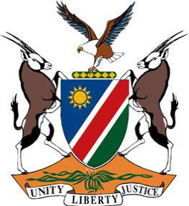

**Statement by Namibia at the 46th Session of the UPR Working Group:**

**Review of Vanuatu, 2 May 2024**

**Mr. President,**

1. Namibia warmly welcomes the distinguished delegation of the Republic of Vanuatu and commends them for ensuring that climate change and disaster risk reduction policies, projects and governance mechanisms are gender responsive.
2. In the spirit of constructive dialogue, we wish to offer the following recommendations:
3. **First,** ratify the Optional Protocol to the Convention on the Rights of Persons with Disabilities.
4. **Second,** review the traditional and legal systems to ensure that provisions on women’s rights are consistent with the Convention on Elimination of All Forms of Discrimination against Women.
5. **Third,** enact legislation to prohibit discrimination and violence against persons with disabilities, particularly against children with disabilities.
6. **Fourth,** adopt legislation to ensure full participation of persons with disabilities in the electoral process as well as their effective representation in all spheres of society, including in decision making positions.
7. To conclude, we wish the distinguished delegation of the Republic of Vanuatu a successful fourth review.