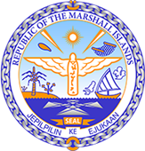

**Republic of the Marshall Islands**

**STATEMENT by H.E Doreen DeBrum**

**46th Session Universal Periodic Review**

**2 May 2024**

**Geneva**

**4th Cycle Review of Vanuatu**

Thank you, Mr. President.

The Marshall Islands welcomes the Hon. John Amos Nalau Masilaiwia and the delegation of Vanuatu. We commend Vanuatu for its pursuit of climate justice and for its leadership in the initiation of the advisory opinion process of the International Court of Justice to better understand the legal obligations of States in relation to climate change.

In the spirit of constructive dialogue, we recommend the following:

1. Continue to empower women economically, socially, and politically.

2. Intensify efforts to promote, protect, and revitalize traditional knowledge and culture.

3. Continue global leadership in pursuing greater international governance and accountability over the human rights implications of climate change.

We wish the delegation every success during its 4th UPR cycle.

Kommol tata and I thank you.