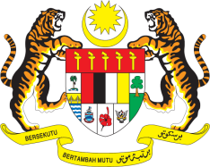

**STATEMENT BY MALAYSIA**

**REVIEW OF VANUATU**

**46TH SESSION OF THE UPR WORKING GROUP**

**29 APRIL – 10 MAY 2024**

Malaysia thanks Vanuatu for the presentation of its national report.

1. Malaysia commends Vanuatu for its continuous efforts to ensure the right to education for its people by strengthening the implementation of the Vanuatu Education and Training Sector Strategic Plan 2021-2030. We are also encouraged by the comprehensive implementation of the National Gender Equality Policy (NGEP) 2021-2030 which provides protection and promotion of the rights of women and girls in Vanuatu.
2. In the spirit of constructive engagement, Malaysia recommends the following:
   1. First, strengthen the education systemby providing free and compulsory primary education for all;
   2. Second, enhance the access to support services for women especially those affected by domestic violence, including provisions for shelters, counselling, healthcare, legal aidand vocational training programmes;
   3. Third, establish training programmes for healthcare personnel in charge of non-communicable diseases; and
   4. Fourth, increase access to health care services for all especially persons with disabilities and those underserved populations in remote areas.
3. We wish Vanuatu a successful review.

Thank you.

**2 MAY 2024**

**GENEVA**