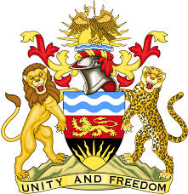

**REPUBLIC OF MALAWI**

**MALAWI STATEMENT ON VANUATU UNIVERSAL PERIODIC REVIEW**

**THURSDAY, 2ND MAY 2024**

**Mr. President**,

Malawi welcomes Vanuatu to this review and thanks the delegation for the comprehensive presentation.

In the spirit of constructive dialogue, Malawi makes the following recommendations:

1. Continue with efforts to combat forced labour, trafficking, and all forms of slavery.
2. Continue with plans to develop the Vanuatu Disability and Inclusion Act.

.

We wish Vanuatu all the best at this review and in the implementation of the recommendations.

**Thank you, Mr. President**.