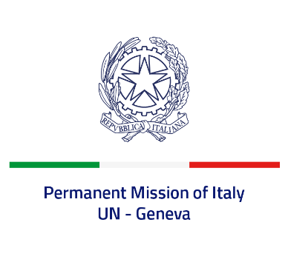

*Check against delivery*

**UPR 46 - Vanuatu**

**Thursday 2 May 2024, 9:00 - 12:30**

**Delivered by: Ambassador Vincenzo Grassi, Permanent Representative of Italy**

Thank you, Mister President.

We thank the distinguished delegation of Vanuatu for the presentation.

Italy welcomes the efforts made by Vanuatu to enforce the National Disability-Inclusive Development Policy 2018-2025 and plans to develop a “Disability and Inclusion Act”.

We also appreciate the integration of a human rights-based approach in all its policies and programmes on climate change response and disaster risk reduction.

Italy seizes this opportunity to offer Vanuatu the following recommendations:

* *Consider acceding to the International Covenant on Economic, Social and Cultural Rights, the International Convention on the Elimination of All Forms of Racial Discrimination and the Optional Protocol to the Convention against Torture and Other Cruel, Inhuman or Degrading Treatment or Punishment;*
* *Implement policies to protect the most vulnerable groups, combat all forms of discrimination and violence, and eradicate human trafficking;*
* *Strengthen the efforts to combat gender discrimination and child, early and forced marriage, including by increasing the minimum age of marriage for girls from 16 to 18 years in line with international human rights standards;*
* *Consider amending the Penal Code to include sexual harassment as a sexual offense.*

We wish Vanuatu a successful review.

I thank you.