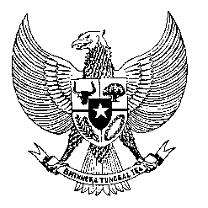

Permanent Mission
of the Republic of Indonesia to the UN, WTO,
and Other International Organizations
in Geneva

STATEMENT BY THE DELEGATION OF THE REPUBLIC OF INDONESIA
AT THE 46th SESSION OF THE UPR WORKING GROUP
CONSIDERATION OF THE UPR REPORT OF VANUATU
2 MAY 2024

Mr. Vice President,

We thank the esteemed delegation of Vanuatu for presenting its national report.

Indonesia shares Vanuatu's profound concerns regarding the severe impacts of climate change and natural disasters. We commend Vanuatu for its unwavering commitment and proactive efforts in addressing the climate crisis and disaster risk reduction at the global level. Indonesia stands prepared to extend its support to Vanuatu's endeavors, whether through bilateral, regional, or multilateral channels.

In a spirit of constructive collaboration to bolster Vanuatu's human rights agenda, Indonesia offers the following recommendations:

- Expedite the establishment of a national human rights institution in accordance with the Paris Principles, to ensure the effective promotion and protection of human rights

- Continuing efforts to combat gender discrimination, harmful practices and violence against women through robust legislation and policy frameworks.

- Strengthen laws and policies to provide enhanced social protection for the population.

We wish Vanuatu a successful review.

Thank you.

153 words/1 minute 45 seconds

