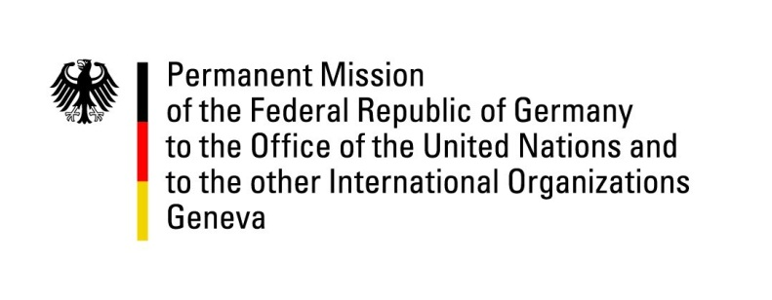

**United Nations Human Rights Council**

**46th Session of the UPR Working Group**

**Geneva, May 2nd, 2024**

**German Recommendations and advance questions to**

**Vanuatu**

Mister President,

Germany welcomes the delegation of Vanuatu.

Germany commends Vanuatu for its leadership on addressing the consequences of climate change, particularly in seeking an advisory opinion from the ICJ on the of effects climate change on the rights of individuals. We also welcome the adoption of the National Gender Equality Policy 2020-2030.

While recognizing the particular challenges Vanuatu faces as a small island developing state, Germany remains concerned, especially about continuously high rates of violence against women and children and discrimination of LGBTQI+-persons.

Germany therefore recommends Vanuatu to

1. Proceed with the establishment of a national human rights institution in compliance with the Paris Principles;
2. Enact quotas for female candidates in elections to provincial councils and the national parliament in line with the best practice of a special quota for municipal elections;
3. Ensure equal rights of LGBTQI+-persons and their families by enacting anti-discrimination laws and recognizing same-sex marriages and de facto relationships as equal in status.

Thank you, Mister President.

**Germany’s Advance Questions to Vanuatu**

1. When will a fully-fledged National Human Rights Institution, with a mandate for oversight on and in accordance with the Paris Principles be put in place?
2. How many cases of domestic violence, particularly against women and children, have been reported since the last UPR? How many of them have been investigated? What plans are in place to enhance the capacity of the judiciary for the most vulnerable persons?
3. What are currently the main challenges the government of Vanuatu is facing with the implementation of the National Gender Equality Strategy 2020-2030?
4. What measures does the government of Vanuatu plan to introduce to prevent discrimination based on sexual orientation and gender identity and to recognise LGBTQI+ individuals, couples, or their families?
5. How will the government of Vanuatu ensure inclusive consultation, particularly with women and marginalised individuals, on the National Advisory Board on Climate Change and Disaster Risk Reduction and other climate change committees?