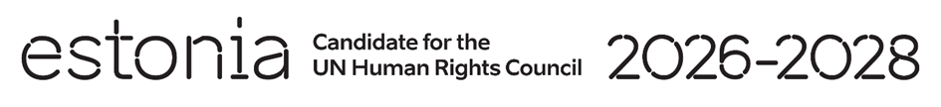

**Universal Periodic Review of Vanuatu**

**2 May 2024**

**Intervention by the delegation of Estonia**

Estonia welcomes the delegation of Vanuatu to its fourth UPR and thanks the delegation for the presentation of its national report today.

We commend Vanuatu for its actions in the context of climate change and natural disasters. We welcome the National Gender Equality Policy 2020–2030 and legislative and policy advances made in the field of access to modern family planning methods. We encourage Vanuatu to continue its efforts to ensure the full enjoyment of all human rights by all women and girls, including in relation to sexual and reproductive rights.

We would like to recommend to Vanuatu to:

* review the civil and traditional legal systems to undertake reforms to ensure that provisions on women’s rights conform to the Convention on the Elimination of All Forms of Discrimination against Women (CEDAW);
* take legislative and political measures and implement existing laws and strategies to eliminate all forms of discrimination, violence and abuse of women and children;
* amend all relevant legislation to prohibit all forms of discrimination on any ground in line with international human rights treaties;
* abolish child, early and forced marriage by eliminating legislative exceptions to the minimum age of 18 years;
* ensure full implementation of child protection-related recommendations of international human rights mechanisms.

We wish to the delegation of Vanuatu a successful review.

Thank you.