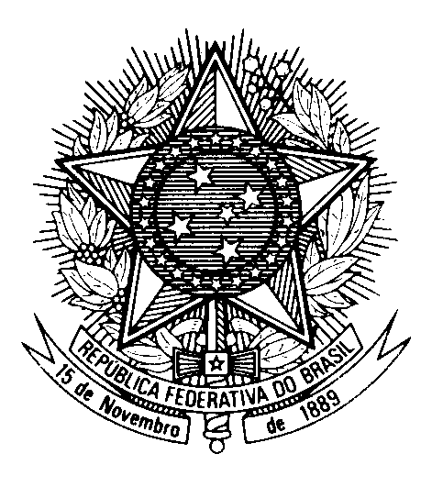
HRC UNIVERSAL PERIODIC REVIEW
VANUATU

(Geneva, May 2nd 2024)

STATEMENT OF BRAZIL

Mister President,

Brazil welcomes the delegation of Vanuatu.

Brazil acknowledges Vanuatu´s measures to promote the right to health, improving access to basic healthcare, particularly in rural areas.

Brazil also praises Vanuatu for its efforts to improve living conditions in detention centers.

Moreover, we encourage Vanuatu to continue its efforts on the issue of human rights-related effects of climate change.

In a constructive spirit, Brazil recommends that Vanuatu:

1) improve the protection on the rights of women, making the necessary changes in its legal system to ensure that provisions on women´s rights are in accordance with the Convention on the Elimination of All Forms of Discrimination against Women, increasing women´s participation in the country´s political life, combatting violence against women, and providing victims with full access to the justice system, including residents of rural and remote areas;

2) take effective measures to retain children in school and increase their attendance, including girls, children with disabilities and students living outside urban centers.

We encourage Vanuatu to ratify the Optional Protocol to the Convention on the Rights of Persons with Disabilities and to amend its national laws, so that the protection of persons with disabilities be in accordance with human rights international standards.

We wish Vanuatu an excellent review.

Thank you.

