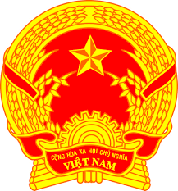

**Statement of the Socialist Republic of Viet Nam**

*46rd Session of the UPR Working Group  
Review of Uruguay*

*(Geneva, 01 May 2024)*

***Time: 1 minute 10 seconds***

*Mister President,*

Viet Nam welcomes and thanks the delegation of Uruguay for its national UPR report.

We commend Uruguay for the progress made in the field of human rights through the adoption of the First National Human Rights Plan in 2023 in establishing the necessary legal, policy, and institutional frameworks to safeguard human rights. We also take note of Uruguay’s efforts in eliminating extreme poverty.

In a spirit of constructive dialogue, Viet Nam has two recommendations to Uruguay:

1. First, continue its efforts to ensure the effective prohibition of gender-based violence through appropriate enforcement mechanisms and awareness raising.

2. Second, continue its efforts to promote and protect the rights of education for children, including taking measures to address inequality in access to education.

Viet Nam wishes Uruguay a successful review.

*Thank you, Mister President./.*