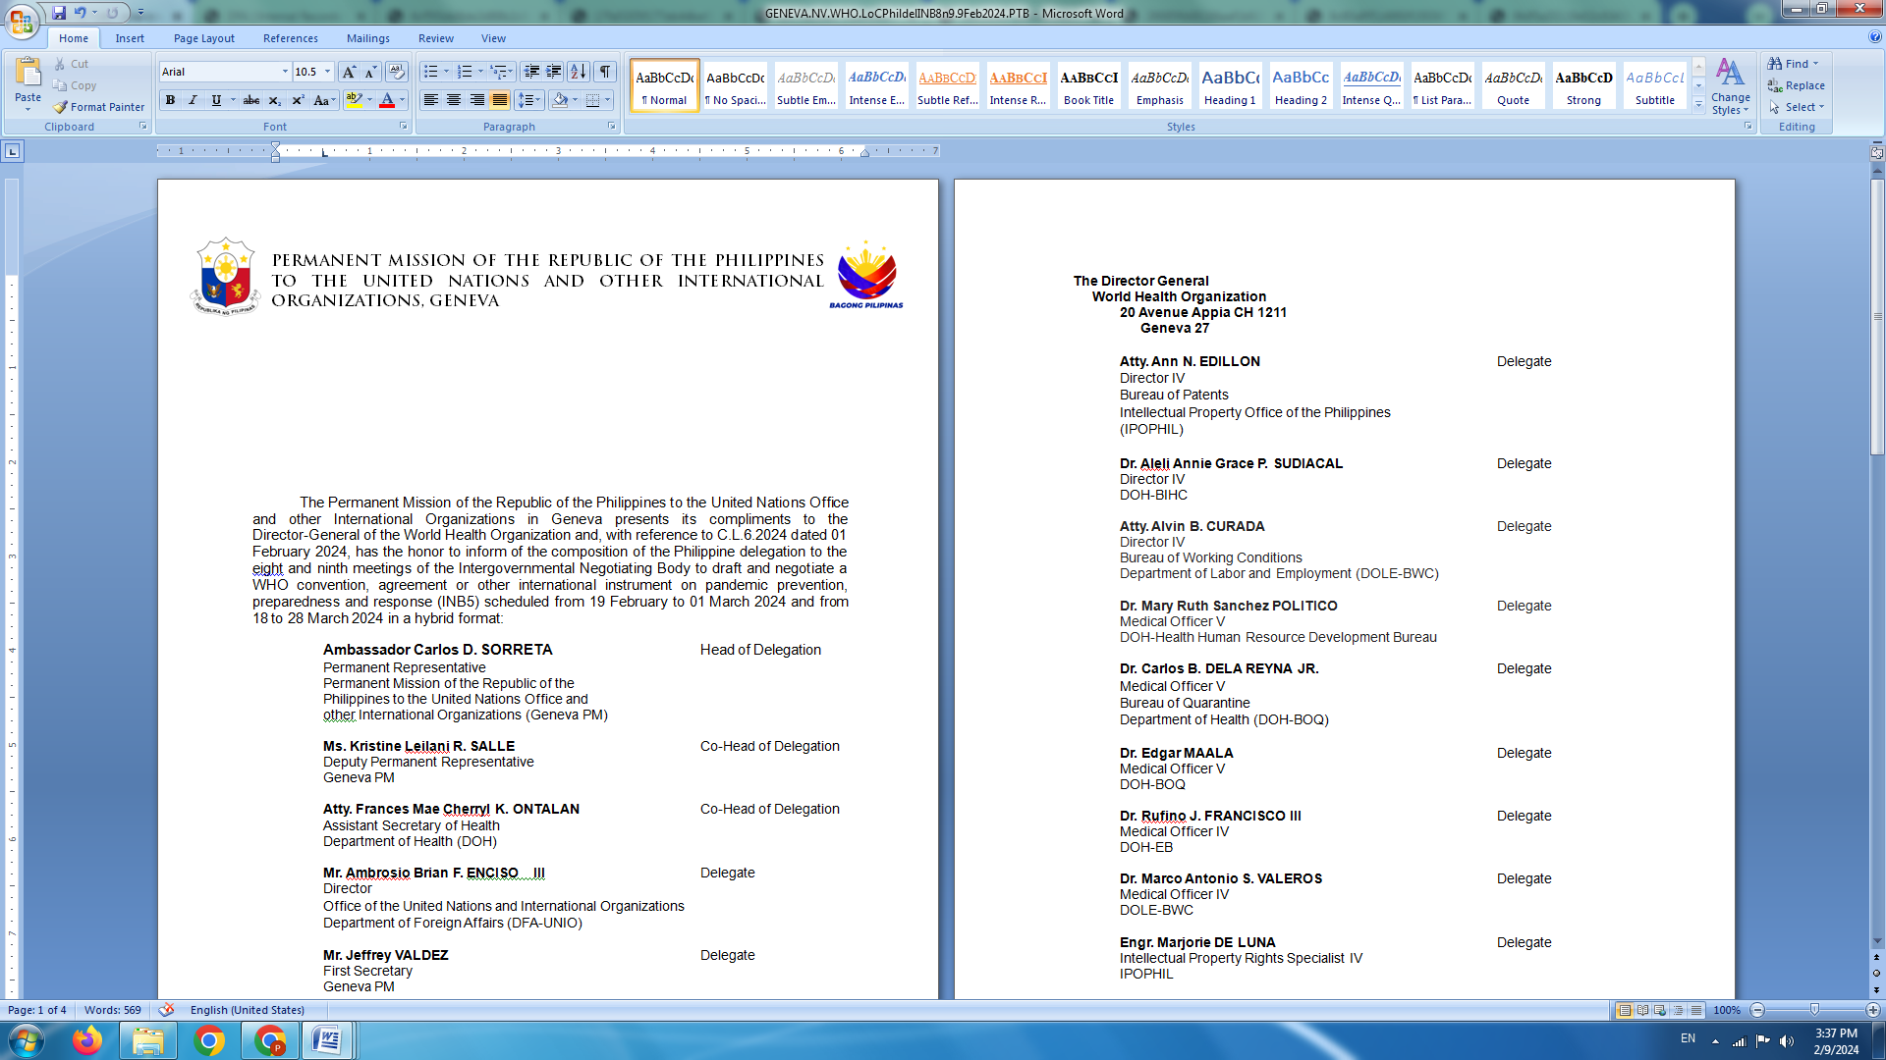

**P H I L I P P I N E S**

**HUMAN RIGHTS COUNCIL**

**46th Session of the Working Group on the Universal Periodic Review**

Palais des Nations, Geneva, Switzerland

1 May 2024, 9:00 AM – 12:30 PM

**REVIEW OF URUGUAY**

*To be delivered by*

**First Secretary Luningning Camoying Valdez**

*Speaking time: 1 minute 10 second*

The Philippines welcomes the esteemed delegation of Uruguay and positively notes the substantive updates on measures taken to strengthen policy and institutional frameworks on human rights during the review period. We particularly laud the adoption of the National Human Rights Plan 2020-2027 and Act No. 19.846 on equality and non-discrimination between women and men.

In a constructive spirit, we recommend the following:

1. Fully enforce relevant laws against gender-based violence, including femicide, through enhanced human rights training for law enforcement officers and well-resourced access to justice and prevention mechanisms, among other measures.
2. Step up efforts to combat child marriage, including by expediting work on the bill raising the minimum age for marriage to 18 years old;
3. Further promote women’s participation and leadership role in the country’s political institutions; and
4. Adopt and effectively implement the National Plan for the Integration of Migrants, Asylum Seekers and Refugees as recommended by the Committee on Migrant Workers.

We wish Uruguay all success in this review cycle. **END.**