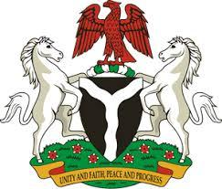

*Please check against delivery*

**HUMAN RIGHTS COUNCIL**

**46TH SESSION OF THE WORKING GROUP OF THE UPR**

**REVIEW OF URUGUAY**

**1ST MAY, 2024**

**STATEMENT BY NIGERIA**

**Mr. President,**

Nigeria welcomes the delegation of Uruguay to the presentation of its National Report and commends the Government for its commitment to international human rights obligations and human rights mechanisms.

2. Nigeria congratulates Uruguay for the adoption of its first national human rights action plan, marking a significant step towards promoting and protecting human rights across the country. We also take positive note of the progress made in protecting the rights of people of African descent.

3. While acknowledging the efforts of the Government of Uruguay to uphold human rights and fundamental freedoms, Nigeria wishes to recommend the following:

1. To intensify efforts to ensure the full enjoyment of human rights by people of African descent, including the elimination of all forms of discrimination and ensuring access to education for children of African descent;
2. To deepen commitment to the protection of life, at all stages, by adopting measures that further prioritize the well-being and dignity of every individual, including unborn children;
3. To ensure that relevant laws and policies respect the rights and duties of parents or legal guardians of children, in accordance with international law; and
4. To intensify efforts to prevent and combat human trafficking, while ensuring the promotion of the rights of victims of trafficking.

4. Finally, we wish Uruguay a very successful review process.

I thank you, Mr. President.