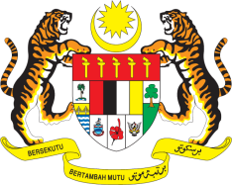

**STATEMENT BY MALAYSIA**

**REVIEW OF URUGUAY**

**46TH SESSION OF THE UPR WORKING GROUP**

**29 APRIL – 10 MAY 2024**

Malaysia thanks Uruguay for the presentation of its national report.

1. Malaysia commends Uruguay’s continuous efforts in advancing human rights for its people and welcomes the progress in implementing recommendations from its previous UPR.
2. In the spirit of constructive engagement, Malaysia recommends the following:
   1. First, strengthen mechanisms to detect, address and punish cases of sexual exploitation of children while providing adequate resources for child protection services;
   2. Second, provide free access to education to all persons with disabilities through full and effective implementation of the “Protocol to ensure the right to an inclusive education for persons with disabilities”; and
   3. Third, undertake full, effective and timely implementation of the 2018 Mental Health Law nationwide, expand mental health services such as outpatient counselling, inpatient care and community-based support programs beyond the capital for equitable access, and effectively execute the National Strategy to Prevent Suicides 2021 – 2025.
3. We wish Uruguay a successful review.

Thank you.

**1 MAY 2024**

**GENEVA**