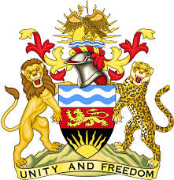

**REPUBLIC OF MALAWI**

**MALAWI STATEMENT ON URUGUAY UNIVERSAL PERIODIC REVIEW**

**WEDNESDAY, 1ST MAY 2024**

**Mr. President**,

Malawi welcomes Uruguay to this review and thanks the delegation for the comprehensive presentation.

In the spirit of constructive dialogue, Malawi makes the following recommendations:

1. Continue with efforts to promote and protect the rights of persons with disabilities.
2. Continue with stepped up measures to combat trafficking in persons, paying particular attention to the trafficking of women, children and adolescents

.

We wish Uruguay all the best at this review and in the implementation of the recommendations.

**Thank you, Mr. President**.