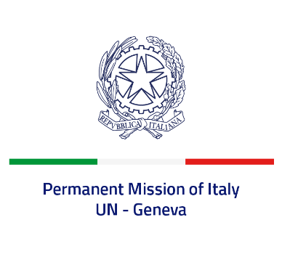

*Check against delivery*

**UPR 46 - Uruguay**

**Wednesday 1 May 2024, 9:00 - 12:30**

**Delivered by: Minister Stefano Pisotti, Deputy Permanent Representative of Italy**

Thank you, Mister Vice President.

We thank the distinguished delegation of Uruguay for the presentation.

Italy welcomes the adoption of the first National Human Rights Plan in 2023 and takes note with appreciation of Uruguay’s voluntary commitment to move forward in its implementation.

Italy seizes this opportunity to offer Uruguay the following recommendations:

•        *Implement measures to counter gender-based and domestic violence, including by providing protection and assistance to the victims through shelters, legal aid and medical care;*

•        *Improve detention conditions by reducing overcrowding in prisons, ensuring that detainees have access to rehabilitation and integration opportunities, and enhancing the use of alternative measures to deprivation of liberty;*

•        *Strengthen efforts to prevent and combat human trafficking in persons, in particular women and girls, including through the reinforcement of victim’s identification systems.*

We wish Uruguay a successful review.

I thank you.