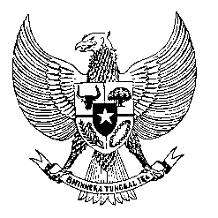

Permanent Mission
of the Republic of Indonesia to the UN, WTO,
and Other International Organizations
in Geneva

STATEMENT BY THE DELEGATION OF THE REPUBLIC OF INDONESIA
AT THE 46th SESSION OF THE UPR WORKING GROUP
CONSIDERATION OF THE UPR REPORT OF URUGUAY
1 MAY 2024

Mr. Vice President,

Indonesia warmly welcomes the esteemed delegation of Uruguay and thanks them for presenting their report.

We commend Uruguay’s commitment to protect children, particular noteworthy are the progressive initiatives offering financial support and healthcare access for orphaned children of individuals who have tragically lost their lives due to domestic violence.

We also welcome Uruguay’s positive efforts in implementing the Convention on the Protection of the Rights of All Migrant Workers and Members of their Families (CMW), including by providing assistance for Indonesian seafarers stationed in Uruguay.

Indonesia recommends Uruguay the following:

- Strengthening efforts to safeguard the exercise of freedom of expression and freedom of the press, including by ensuring adequate protection for journalists and other individuals exercising these freedoms.
- Redouble efforts to protect women from femicide.
- Continue its efforts in combating human trafficking, including by providing necessary resources for the effective implementation of the National Action Plan 2022-2026 as well as the new law on the prevention and combating of trafficking in persons.

We wish Uruguay a successful review.

Thank you.

176 words/1 minute and 10 seconds

