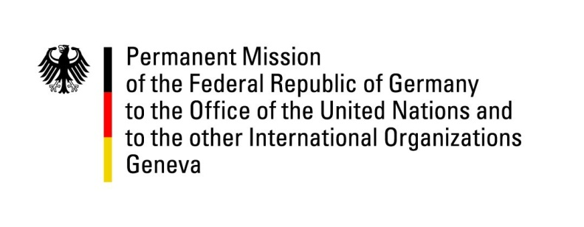

**United Nations Human Rights Council**

**46th Session of the UPR Working Group**

**Geneva, 1 of May 2024**

**German Recommendations and advance questions to**

**Uruguay**

Mister President,

Germany welcomes the delegation of Uruguay.

Germany commends Uruguay for its strong human rights record in general and for the recent advances in addressing violence against women in particular. Germany also commends Uruguay´s constructive engagement with the UPR mechanism.

However, Germany remains concerned about remaining challenges with respect to violence against women and in relation to the rights of prisoners and detention conditions.

Germany therefore recommends to:

* Enhance measures for preventing violence against women by even further expanding territorial helpline services and increasing the number of shelters to protect women in situations of violence, especially in areas outside of departmental capitals.
* Implement effective measures aimed at alleviating overcrowding in prisons.
* Ensure that individuals deprived of liberty have access to opportunities for rehabilitation and integration, in alignment with recommendations put forth by both national and international organizations.

Thank you, Mister President.