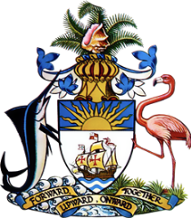

**Statement by  
 Permanent Mission of The Bahamas to the United Nations Office and other International Organizations in Geneva**

**at the 46th Session of the Universal Periodic Review Working Group**

***Presentation of UPR Report by Uruguay* 1May 2024**

Thank you, Mr. President,

The Bahamas thanks Uruguay for presenting its comprehensive report and commends the substantial progress made since the last review.

We commend Uruguay's unwavering dedication to human rights, underscored by its strict adherence to international treaties and effective national programs. The adoption of its first National Human Rights Plan and the significant role of its National Human Rights Institution and Office of the Ombudsman, especially in addressing the disappearances of persons, are particularly noteworthy. Uruguay’s efforts to combat torture, protect the rights of children, adolescents, and persons with disabilities reaffirm its leadership in human rights across the Americas and globally.

In a constructive spirit, The Bahamas recommends that Uruguay:

1. Continue to strengthen its efforts in the prevention of torture and cruel treatment by expanding the capacity and reach of its national preventive mechanism, ensuring comprehensive oversight of all places of detention.
2. Enhance the educational framework to further support youth development, focusing on integrating human rights education and ensuring equitable access for all, including those in remote and underserved areas.
3. Enhance efforts to integrate climate change mitigation and adaptation strategies into national development policies in light of Uruguay's established commitment to environmental sustainability.

We extend our best wishes to Uruguay for a successful review.

I thank you.