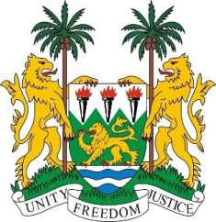

**SIERRA LEONE**

**46th Session of the UPR Statement**

**The Slovak Republic**

Monday, 6 May, 2024

**Madam Vice President**,

Sierra Leone extends a warm welcome to **H.E. Ms. Miroslava Vozáryová, Secretary General of the Ministry of Foreign and European Affairs**, and the esteemed delegation of the Slovak Republic, and thanks it for the presentation of its national report.

We commend Slovakia for its proactive stance in tackling inequalities and anti-social activities. We welcome the Strategy for Gender Equality and Equal Opportunities 2021-2027, which aims to reduce disparities between men and women and eliminate discrimination against women. In addition, the Strategy for Equality, Inclusion and Participation of Roma until 2030 is a positive step towards promoting the rights and well-being of the Roma community.

We also acknowledge Slovakia's efforts to combat racism, xenophobia, radicalism and extremism. The adoption of the Conceptual Framework for Countering Radicalism and Extremism until 2024 demonstrates Slovakia's commitment to combating these challenges and promoting social cohesion.

In a spirit of constructive dialogue, Sierra Leone offers the following recommendations for Slovakia`s consideration.

1.    Continue efforts to combat discrimination against foreign residents and workers, particularly those of African descent.

2.    Ensure that victims of racial discrimination have access to justice under the Anti-Discrimination Act.

3.    Continue to promote gender equality and protect women's rights.

Sierra Leone extends its best wishes to Slovakia Republic for a successful fourth cycle review.

**Thank you, Madam Vice President.**