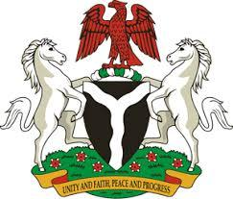

*Please check against delivery*

**HUMAN RIGHTS COUNCIL**

**46TH SESSION OF THE WORKING GROUP OF THE UPR**

**REVIEW OF SLOVAKIA**

**6TH MAY, 2024**

**STATEMENT BY NIGERIA**

**Mr. President,**

Nigeria welcomes the delegation of Slovakia to the presentation of its National Report for the Fourth UPR Cycle and commends the Government for its commitment to international human rights obligations and human rights mechanisms.

2. Nigeria commends the Government of Slovakia for its commitment to social inclusion and human rights. In particular, Slovakia’s frameworks and action plans to tackle poverty, advance disability rights, empower women and prevent violence against women and children, are noteworthy.

3. In the spirit of constructive dialogue, Nigeria wishes to recommend to Slovakia as follows:

1. To consider further necessary measures to ensure the protection of the rights of migrants, including through the ratification of the Convention on the Protection of the Rights of all Migrant Workers and Members of their Families; and
2. To intensify efforts to prevent and combat human trafficking while ensuring the promotion of the rights of victims of trafficking.

4. We wish Slovakia a very successful review process.

I thank you, Mr. President.