*Check against delivery*

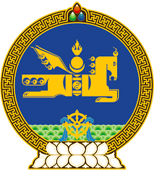

**46th SESSION OF THE UPR WORKING GROUP**

**MONGOLIA’S STATEMENT AT THE REVIEW OF SLOVAKIA**

**6 May 2024, 09:00 - 12:00 hrs**

(1 min 20 sec)

Thank you, Mr. President.

The delegation of Mongolia extends a warm welcome to the delegation of Slovakia.

Mongolia commends Slovakia for the legislative reforms to promote gender equality and address violence against women and children, including through adoption of various important legal acts such as the National Action Plan for the Prevention and Elimination of Violence against Women (2022-2027), Strategy for Gender Equality and Equal Opportunities (2021-2027) and the National Strategy for the Protection of Children from Violence (2023-2029).

We also welcome Slovakia’s ratification of the Optional Protocol to the Convention against Torture and other Cruel, Inhuman or Degrading Treatment or Punishment.

In the spirit of constructive dialogue, Mongolia recommends Slovakia to:

**One.** Strengthen its legislation governing the functioning of the national human rights institution in compliance with the Paris Principles;

**Two.** Further enhance its efforts to combat trafficking in persons including through increasing penalties and by ensuring the effective implementation of its new National Programme for Combating Human Trafficking for 2028.

We wish the delegation of Slovakia a productive review.

I thank you.

---oOo---