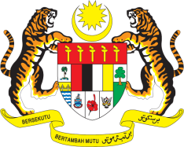

**STATEMENT BY MALAYSIA**

**REVIEW OF SLOVAKIA**

**46TH SESSION OF THE UPR WORKING GROUP**

**29 APRIL – 10 MAY 2024**

Malaysia thanks Slovakia for the presentation of its national report.

2. Since the previous UPR, Slovakia has demonstrated progress in addressing racism, xenophobia and hate speech related to race, nationality, ethnicity and religion. Malaysia commends Slovakia for its endeavours in promoting economic and social development in the country.

3. In the spirit of constructive engagement, Malaysia recommends the following:

* 1. First, take measures to effectively implement the prohibition of racism, discrimination and hate crime through increased awareness campaigns and measures to combat stereotypes and prejudices.

3.2 Second, take immediate step without delay to create community-based social services for all persons with disabilities, including children with disabilities and people with complex support needs, so they are accessible to education, employment, transportation and public services.

4. We wish Slovakia a successful review.

Thank you.

**6 MAY 2024**

**GENEVA**