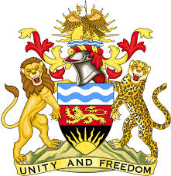

**REPUBLIC OF MALAWI**

**MALAWI STATEMENT ON SLOVAKIA UNIVERSAL PERIODIC REVIEW**

**MONDAY, 6TH MAY 2024**

**Mr. President**,

Malawi welcomes Slovakia to this review and thanks the delegation for the comprehensive presentation.

In the spirit of constructive dialogue, Malawi makes the following recommendations:

1. Continue with efforts to ensure rehabilitation and redress for victims of torture and cruel, inhuman, or degrading treatment.
2. Take all necessary measures to eliminate obstacles in obtaining access to justice encountered by women and girls who faced intersecting and multiple forms of discrimination.
3. Work towards lifting the reservation to article 27 of the Convention relating to the Status of Stateless Persons and develop a national action plan on statelessness.

We wish Slovakia all the best at this review and in the implementation of the recommendations.

**Thank you, Mr. President**.