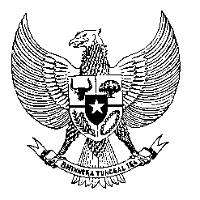

Permanent Mission
of the Republic of Indonesia to the UN, WTO,
and Other International Organizations
in Geneva

STATEMENT BY THE DELEGATION OF THE REPUBLIC OF INDONESIA
AT THE 46th SESSION OF THE UPR WORKING GROUP
CONSIDERATION OF THE UPR REPORT OF SLOVAKIA
6 MAY 2024

Madame Vice President,

We thank the esteemed delegation of the Slovak Republic for presenting its national report.

We commend the Slovak Republic for its establishment of a national prevention mechanism and legislative reforms to ensure the rights and well-being of vulnerable groups, including women and children who have suffered violence.

While acknowledging these efforts, Indonesia recommends the following:

- Enhance the protection of all migrant workers through national legislation, including their access to legal remedies, healthcare, and fair labor practices, which aligns with international human rights standards.

- Strengthen efforts to combat hate speech, discrimination, racism, and extremism and improve its victim support framework to ensure adequate access to justice and protection.

- Take further steps to ensure inclusive educational environments for all children, including children with disabilities and from minority groups.

We wish the Slovak Republic a successful review.

Thank you.

