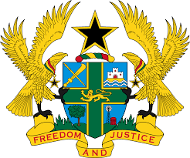

**STATEMENT TO BE DELIVERED BY GHANA DURING THE 46TH SESSION**

**OF THE UPR WORKING GROUP, ON MONDAY, 6TH MAY, 2024**

**UNIVERSAL PERIODIC REVIEW OF SLOVAKIA**

Madam Vice- President.

2. My delegation applauds the Government of Slovakia for its commitment to the advancement of human rights both domestically and internationally. We further commend the efforts made to approve the National Action Plan for the Prevention and Elimination of Violence against Women, as well as the National Strategy for the Protection of Children from Violence.

3. We also recognise Slovakia’s steady progress towards improving the educational system by developing a strategy of inclusive approach in education and training, aimed at ensuring quality educational outcomes for all children.

4. In the spirit of constructive engagement, Ghana offers the following three (3) recommendations for Slovakia’s consideration:

1. Adopt measures to the ensure the promotion and protection of labour rights;
2. Ensure that law enforcement agencies, including the police continuously comply with international policing standards; and
3. Establish a national accommodation and housing strategy to integrate the most vulnerable groups within local communities.

5. We wish Slovakia a successful review process.

I thank you.