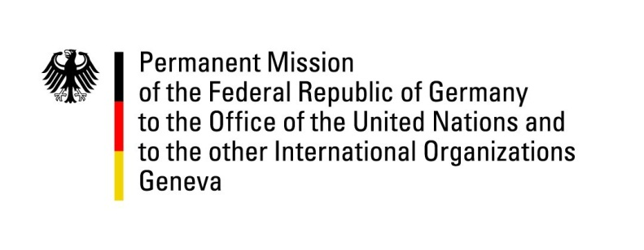

**United Nations Human Rights Council**

**46th Session of the UPR Working Group**

**Geneva, 6th of May 2023**

**German Recommendations and advance questions to**

**Slovakia**

Mister President,

Germany welcomes the delegation of Slovakia.

Germany commends Slovakia for ratifying the Optional Protocol to the Convention against Torture and Other Cruel, Inhuman or Degrading Treatment or Punishment in May 2023.

However, Germany remains concerned about recent rhetoric and developments regarding independent journalism, the rights of minorities, especially Roma and refugees, and the rule of law.

Germany therefore recommends to:

* continue efforts to reduce segregation and to integrate the Roma community, especially through ensuring equal access to all levels of education for every child regardless of their ethnicity and implement programs to enhance their equal access to health services, housing and employment.
* adopt measures to strengthen the mandate of its national human rights institution so that it is fully compliant with the Paris Principles.
* adopt a national action plan to implement the Guiding Principles on Business and Human Rights.
* ratify the Council of Europe Convention on Preventing and Combating Violence against Women and Domestic Violence (Istanbul Convention).

Thank you, Mister President.

**GERMAN ADVANCE QUESTIONS TO SLOVAKIA:**

* What steps is Slovakia taking in order to facilitate more participation of civil society in human rights matters? Why was there no participatory consultation process in establishing the National Human Rights Report (as opposed to previous occasions)?
* Will the government continue to provide adequate funding to the Office of the Public Defender of Human Rights and the National Centre for Human Rights so they will be able to fulfill their mandates?