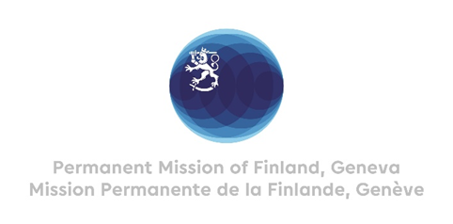

**46th Session of the UPR working group**

**Recommendations by Finland to Slovakia**

**6th May 2024**

Mr. President,

Finland welcomes the engagement of Slovakia in the UPR process.

Finland respectfully recommends:

1. One, to take additional measures to strengthen the national human rights institution in accordance with the Paris Principles
2. Two, to continue efforts in reducing segregation and integrating the Roma community, especially in ensuring equal access to all levels of education for every child , in line with Slovakia’s international human rights obligations, and implement programmes to enhance their equal access to health services, housing and employment
3. Three, to adopt a comprehensive action plan for the rights of LGBTI+ persons, including targeted measures to end discrimination against them and improving accessibility of medical transition and legal gender recognition.

I thank you.