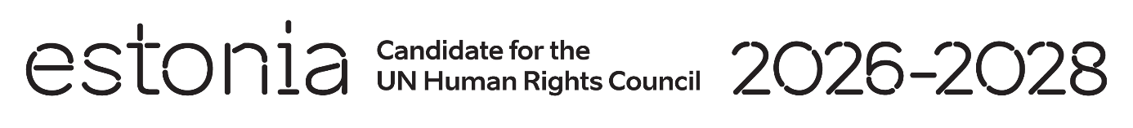

**Universal Periodic Review of Slovakia**

**6 May 2024**

**Intervention by the delegation of Estonia**

Estonia warmly welcomes the delegation of Slovakia to its fourth UPR and thanks the government for the national report and the information provided today.

Estonia commends Slovakia’s commitment to comply with international obligations and promote and protect human rights. We also praise Slovakia for initiatives to address the issue of political representation of women and to reduce the gender pay gap.

However, we remain very concerned about the reports of political pressure imposed on media freedom and we urge the government to protect the freedom of the press in Slovakia.

We would like to recommend to:

* clearly and unambiguously ban the use of corporal punishment of children, including when exercising parental rights and obligations;
* revise the Anti-Discrimination Act to eliminate any form of discrimination against women in all areas covered by Article 2 of the Convention on the Elimination of All Forms of Discrimination against Women;
* fulfil all obligations to effectively protect media freedom, the safety of journalists and media workers.

Estonia wishes to the delegation of Slovakia a successful review.

Thank you.