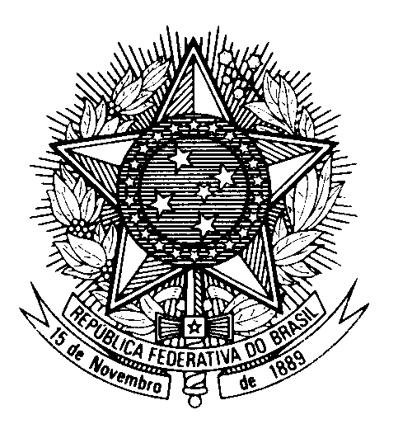

Statement of Brazil in the review of Slovakia,

during the 46th session of the Working Group on the UPR

(Geneva, 6 May 2024)

Thank you, Mr. President.

We commend the ratification, in July 2023, of the Convention against Torture, and the approval of policies to combat radicalization and extremism, as well as violence against women and children, and encourage the ratification of the OPCAT.

We also commend efforts to improve the living conditions of people with disabilities, to combat poverty and to promote gender equality.

In a spirit of constructive engagement, Brazil recommends Slovakia to:

1) Adopt effective measures to ensure that minority children, including Roma, can be fully integrated into society, including through programmes to encourage the enrolment in schools and the adoption of necessary measures to break the cycle of stigma and discrimination; and

2) Adopt a comprehensive action plan on the rights of LGBTQIA+ people, in line with the commitment made in the National Strategy for the Protection and Promotion of Human Rights, of 2015.

We encourage sSovakia to revise its anti-discrimination act to eliminate any form of discrimination against women.

Thank you.

