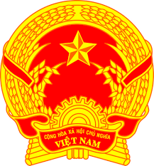

**Statement of the Socialist Republic of Viet Nam**

**At the 46th Session of the UPR Working Group  
Review of North Macedonia**

*(Geneva, 02 May 2024)*

**Speaking time: 1 minute 45 seconds**

*Mister President,*

Viet Nam is pleased to welcome and thank the delegation of North Macedonia for the comprehensive presentation of the national UPR report.

Viet Nam welcomes of significant achievements made by the Government of North Macedonia in legislative and policy reform, including new laws on compensation of victims of violent crimes, prevention of corruption, protection against discrimination, to name a few.

In a spirit of constructive dialogue, Viet Nam would like to make 02 recommendations:

1. Continue its efforts in ensuring the right to education for every child, as well as the right to education in mother tongue for all ethnic minority groups.

2. Take steps in establishing effective operationalization of the Law on Prevention and Protection from Violence against Women and Domestic Violence.

We wish the delegation of North Macedonia a successful outcome of the review.

*Thank you, Mister President./.*