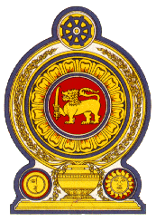

46th Session of the Universal Periodic Review

**Review of North Macedonia**– 2nd May 2024

Statement by the Democratic Socialist Republic of Sri Lanka

Mr. President,

Sri Lanka thanks the delegation of North Macedonia for the presentation made.

Sri Lanka notes the measures taken by North Macedonia since its last UPR with regard to gender equality, women’s entrepreneurship and economic empowerment.

Sri Lanka recommends that North Macedonia;

1. Ratifies the International Convention on the Protection of the Rights of All Migrant Workers and Members of Their Families.
2. Strengthen steps in implementing and enforcing the anti-trafficking infrastructure including prosecuting and convicting more human traffickers and increasing sentences for offenders beyond the minimum.
3. Address gaps and ensure the enforcement of existing laws prohibiting all forms of discrimination in line with international standards and strengthen public education campaigns to promote tolerance, coexistence, respect for diversity, dialogue and inclusion.
4. Adopt a plan for universal health coverage with primary health care for all, including for Roma and rural population.

We wish North Macedonia success in its UPR engagement.