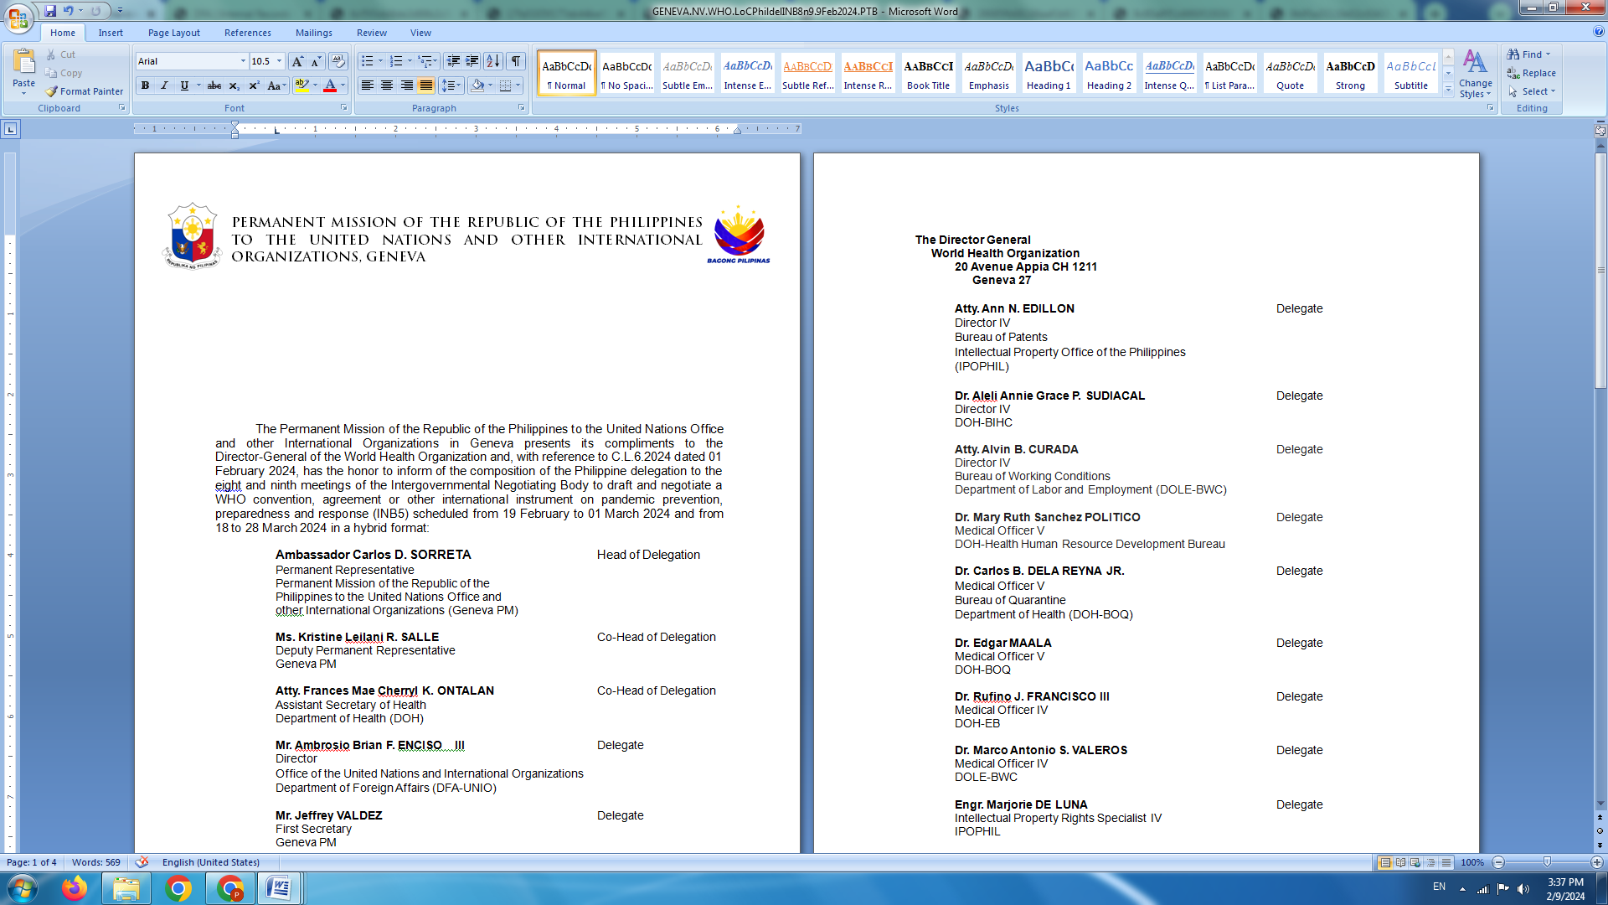

**P H I L I P P I N E S**

**HUMAN RIGHTS COUNCIL**

**46th Session of the Working Group on the Universal Periodic Review**

02 May 2024, Palais des Nations, Geneva, Switzerland

**UNIVERSAL PERIODIC REVIEW OF NORTH MACEDONIA**

Delivered by

First Secretary Luningning Camoying Valdez

Speaking time: 1 minute 45 seconds

The Philipines warmly welcomes the delegation of North Macedonia.

We acknowledge the progress made in implementing previous UPR recommendations, including on aligning domestic legislative and policy frameworks with international human rights obligations and standards, especially on gender equality and children’s rights.

We also note the justice sector reforms and other measures taken to strengthen the rule of law and good governance.

In a constructive spirit, the Philippines recommends that North Macedonia:

1. Continue administering specialized training and education for law enforcement officers, prosecutors and judges on human rights-based approaches to dealing with cases of gender-based discrimination and violence; and
2. Strengthen mechanisms to facilitate the birth registration of all, including those belonging to the Roma community, migrants, refugees, and asylum-seekers in order for them to enjoy their rights, particularly the right to health, social protection, and education.

We likewise reiterate our recommendation for North Macedonia to ratify the International Convention on the Protection of the Rights of All Migrant Workers and Members of Their Families.

The Philippines wishes North Macedonia all success in this UPR review. Thank you. **END**