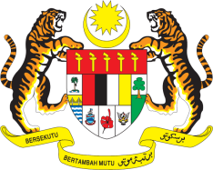

**STATEMENT BY MALAYSIA**

**REVIEW OF NORTH MACEDONIA**

**46TH SESSION OF THE UPR WORKING GROUP**

**29 APRIL – 10 MAY 2024**

Malaysia thanks North Macedonia for the presentation of its national report.

2. We commend North Macedonia for its efforts in strengthening the rule of law and judiciary independence, fighting against corruption, promoting transparency and ensuring good governance through the establishment of various bodies and commissions. We also welcome North Macedonia’s commitment to promote gender equality, ensure non-discrimination for Roma people and the protection of rights of women, children, persons with disabilities and other vulnerable groups.

3. In the spirit of constructive engagement, Malaysia recommends the following:

3.1 First, accelerate efforts to improve the delivery of public services through digitalization of essential services;

3.2 Second, intensify efforts to tackle hate crime, Islamophobia, racism, racial discrimination, xenophobia and other related intolerance directed at ethnic and religious minorities; and

3.3 Third, continue strengthening the social protection programmes for disadvantaged and marginalised groups, especially persons with disabilities.

4. We wish North Macedonia a successful review.

Thank you.

**2 MAY 2024**

**GENEVA**