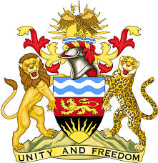

**REPUBLIC OF MALAWI**

**MALAWI STATEMENT ON NORTH MACEDONIA UNIVERSAL PERIODIC REVIEW**

**THURSDAY, 2ND MAY 2024**

**Mr. President**,

Malawi welcomes North Macedonia to this review and thanks the delegation for the comprehensive presentation.

In the spirit of constructive dialogue, Malawi makes the following recommendations:

1. Continue with all efforts to ensure the protection of refugees and migrants.
2. Continue with the comprehensive multidisciplinary approach to combating human trafficking.

We wish North Macedonia all the best at this review and in the implementation of the recommendations.

**Thank you, Mr. President**.