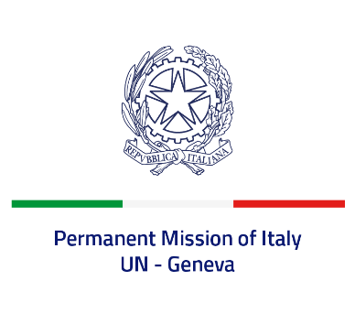

*Check against delivery*

**UPR 46 – North Macedonia**

**Thursday 2 May 2024, 14:30 – 18:00**

**Delivered by: Permanent Representative of Italy Amb. Vincenzo Grassi**

Thank you, Mister President.

We thank the distinguished delegation of North Macedonia for their national report and presentation.

Italy appreciates the commitment of North Macedonia to the UPR and welcomes the efforts to improve the protection of human rights at national level, including with regard to gender equality and the rights of persons with disabilities.

Italy would like to recommend to:

* *Improve the quality of prison conditions, ensuring the rights of detainees and in particular protection of the most vulnerable persons*;
* *Continue the efforts in combatting against all forms of discrimination, including against women and persons with disabilities, implementing national strategies and international conventions and strengthening the capacity of the public administration, both in terms of granting the protection of human rights and ensuring proper prosecution of violations*;
* *Strengthen efforts in the fight against corruption in public administration*;
* *Ratify the Convention for the Protection of All Persons from Enforced Disappearance*.

We wish the delegation of North Macedonia a successful review.

*I thank you*.