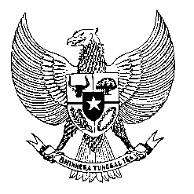

Permanent Mission

of the Republic of Indonesia to the UN, WTO,

and Other International Organizations

in Geneva

**STATEMENT BY THE DELEGATION OF THE REPUBLIC OF INDONESIA**

**AT THE 46th SESSION OF THE UPR WORKING GROUP**

**CONSIDERATION OF THE UPR REPORT OF NORTH MACEDONIA**

**2 MAY 2024**

**Mr. Vice-President**

* We thank North Macedonia for its comprehensive report.
* We welcome North Macedonia’s continued commitment to advance the rights of women as translated into various legislative and policy initiatives, including on…
* gender equality, protection from gender-based violence, social security for women farmers, empowerment for women entrepreneurs as well as mothers’ health.
* To further support human rights implementation in North Macedonia, Indonesia recommends the following:
  1. Continue efforts to accede to the International Convention on the Protection of the Rights of All Migrant Workers and Members of Their Families.
  2. Accelerate the process of establishing a new draft labour law to provide better protection for all workers, including women and persons with disabilities.
  3. Intensify measures to ensure universal access to quality basic health-care services for all people and improve the capacity of health-care professionals.
* Finally, we wish North Macedonia every success in its UPR process.
* Thank you.

*Word counts: 142.*

*Time limit: 1 minute 45 seconds.*