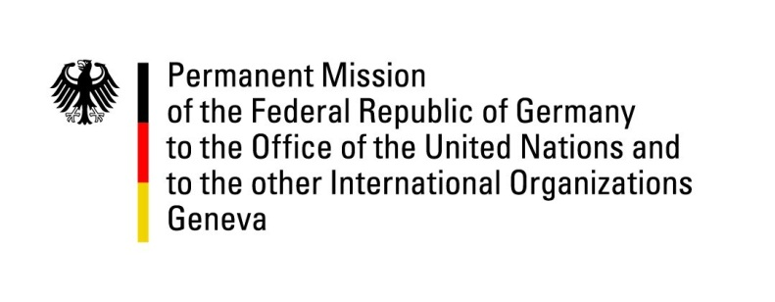

**United Nations Human Rights Council**

**46th Session of the UPR Working Group**

**Geneva, 2 May 2024**

**German Recommendations and advance questions to**

**North Macedonia**

Mister President,

Germany welcomes the delegation of North Macedonia.

Germany congratulates North Macedonia for ending statelessness in almost all known cases through the new “Law on Civil Registry” and for supplying many formerly stateless persons with birth certificates. Germany further welcomes the ratification of the “Istanbul Convention” and especially the progress made so far regarding its implementation.

However, Germany remains concerned about insufficient safeguards against discrimination and infringements on citizen’s rights, unsatisfying conditions in detention facilities, remaining gender inequality and a lacking framework for the recognition of transgender individuals.

Germany therefore recommends to:

* take effective measures to bring conditions in detention and other closed facilities in line with international standards, notably with regard to the overcrowding of prisons and access to healthcare and strengthen efforts for resocialization,
* further strengthen the Office of the Ombudsperson (e.g. by filling the vacant positions of deputy Ombudsperson) and the Commission for the Prevention and Protection against Discrimination (CPPD) (i.e. through an in-depth-review of obstacles in the current legal and policy frameworks and their implementation) and ensure an impartial, independent and solely merit-based selection of personnel as well as allocation of adequate funding,
* adopt a Gender Equality Law in accordance with EU and UN standards and a quick, transparent and accessible administrative legal gender recognition procedure along with adequate funding.

Thank you, Mister President.